VISUAL BASIC 6.0
PREPARED BY S.KALAISELVI/R.KANAKARAJ/R.LATHA
UNIT – 1
First step with Microsoft visual basic 6.0 : integrated development environment ; first program in VB: introduction to forms : common properties , methods and events.
UNIT – 2
Intrinsic controls: text box controls, labels and frame controls , command button , check box and option button controls , list box and combo box picture and image controls. Drive – list box , dir list box and file box xontrol and other controls, control arrays
UNIT – 3
variables and procedures : scope and life time of variables . native data types and aggregate data types – array . VB for application and VB for libraries : control flow , working with numbers , string , date and time
UNIT – 4
Database : data access SAGA, visual data base tools, ADO data binding , data environment designer , crash course in SQL . database programming : ADO at work – setting up a connection processing data
UNIT – 5
Tables and reports – data grid control , flex grid control , data report designer

UNIT – I
VISUAL BASIC 6.0
Visual: graphics pixels
Basic: coding
Programming ->VB->standard.Exe->form.
=>to run the Vb program press f5.
=> To save the VB program use following extensions.
*.Vbp
*.frm

MICROSOFT VISUAL BASIC 6.0
FIRST STEP IN MS VB 6.0
IDE- application creating, writing the coding, testing the coding executing the coding.
Creating applications and writing the codings. The code will be tested and produce executable files. That file should be independent.
RUNNING THE IDE:
Com components:
Controls:
OLE
ADO
ODBC
SELECTING THE PROJECT TYPE:
Microsoft visual basic 6.0
Recent
Existing
New

Wizard.Exe
Active.Exe
Standard .Exe

TOOL BOX PROPERTIES
1. Pointer
Maximizing and minimizing form design
2. Label
Display the text but it cannot be modify
3. Text
Display the text but it can be modify
4. Frame control
Controlling the functions
5. Check box:
Giving the format like true () or false (), yes or no.
6. Combo box
Display the text at a time of clicking file option
We can select more than one option in combo box but it cannot in list box
7. List box
8. ‘H’ and ‘V’ scroll bar
Select the value within a range
9. Timer control
To specify the intervals like seconds, minutes.
10. Directory list box
To select directories c:\
11. Shape controls
12. Image controls
Icons, bitmaps, Meta files
13. OLE controls
Object linked embedded
14. Command Button
To carry out the specify actions
15. Option button or radio button
Displaying some particular things like enable & disable

IDE WINDOWS:
- Project window
- Form design
- Tool box
- Code window
- Properties window
- Form layout
- Immediate window
- Project window
Gives over view of all modules, that modules will contain in applications,, that module will be displayed in grouped form that is in alphabetical order by clicking on the right mouse icon on the project windows tool bar.
- Form designer
- Design applications on user interface
- Application can contain multiple forms
- Open any number of forms at a time in both VB 5.0 and 6.0
- Set of object can be placed on a form
- Fixed set of controls called intrinsic controls.
- Code window
- To write code that determines the behavior of form and object of applications
- Keep any number of code windows visible at a time.
- Split code window in two distinct and independent position by dragging
- Properties window
- List all the properties of the object that currently selected and arranged in alphabetical order and also group them
- Change fore ground and back ground colors. If it is not visible press “F4” or by clicking tool box icon on the “ TOOL BAR”
- Form layout
- Form will be displayed when the program runs.
- Immediate windows
- Temporary suspends while running program
MENUS:
- File
- View
- Project
- Format
- Debug
- Run
- Query
- Diagram
- Tools
- Add-ins
- Windows
- Help

- File
* load and save a VB project or group of project
*VB 6.0 can open multiple projects to save the current module
* To print the entire project or selected project
* To built the executable files
- Edit
  - Editing command include cut copy, paste , find ,replace , undo and redo.
  - It also include bunch of commands related to Microsoft intelligence
- View
  - Database related commands
- Project
  - Add modules include forms, standard modules, class modules, user control module , designer module among this standard modules , class modules , user control modules are also used for reference.
- Format
  - Align and resize one or more controls on a form
  - Centre a control
  - Increase and decrease the distance among the group of controls
- Debug
  - Testing an application with in a integrated development environment
  - Execute the codes step by step
  - Display the values of variables and expressions
- Run
  - Command start the execution of the application
- Query
  - It is available only in VB Enterprises
- Diagram
New text
Add related tables
Show relationship labels
Modify custom view
View page breaks

- Tool
  - Tool menu contains option command and it access only in dialog box by customize IDE.
- Add –ins
  - Collection of commands related to external modules
- Windows
  - It is applicable only in MDI applications
- Help

TOOL BARS:
- Tool bars include common commands are loading, saving the project, running the program and opening.
- Debug, edit and form editors are visible only after right click on the standard tool bar.
CUSTOM TOOL BAR
- Project menu
- Comment block
- Uncomment block
- Command from the edit tool bar
- Book marks sub menu from edit tool bar
- Option command from the tools.
Adding controls to a form launch visual basic standard. Exe project
Design time create forms and other variables
Form design- defined the appearance of the main window of the application
Run time – a limited ability to modify the code

Setting a properties of controls
- Label controls
- Border style
- Text box
- Caption property
- Control

Naming controls
- Name property - string of character that identifies the control in code.
- Default assigning name are label1, text1, command1.

Control/ class | Prefix
Command button | Cmd
Text box | Txt
Picture box | Pic
Label | Lbl
Option button | Opt
Check box | Chk
Combo box | Cbo
List box | Lst
Timer | Tmr
Frame | Fra
Data | Dat
H scroll bar | Hsb
V scroll bar | Vsb
Drive list box | Drv
Dir list box | Dir
File list box | Fil
Line | Lin
Shape | Shp
OLE | Ole
Form | Frm

Moving and resizing controls:
- Select one or more controls and move them as a single entity using the mouse
- Move one or more controls with arrow keys while pressing the control key
- X and Y axis are determined by the grid control or grid units
- Resize the selecting controls by using the arrow keys , while press the ‘shift’ key
- Center a control or a group of controls on the form horizontally and vertically while using the centre in form sub menu
- Align a group of controls or align a sub menu
- Align or resize the controls by selecting them , pressing “F4” to display the properties window.
Setting the tab order
- TAB key is set to be logical order, search order is known as TABORDER sequence.
- Correct tab order sequence assign with tab index property
- Tab index property starts with ‘0’ to the text width controls and ‘1’ to the text height control tab index property
Adding code
- In command button “cmdsum”
- Dim statement is used to specify data type.
- Option explicit statement is use to verify default errors.
Running and debugging the program
- Clicking the procedure, while program is in design mode that mode is called toggle break event command from the debug menu or press ‘F9’ in keyboard.
Refining the sample program
- First time defining is very simple text parameter and text area controls are used to show the result of the competition.
- To increase the application consistency and use ability
- To double click the control to create the “sub” and “end sub” template
Exit sub statement
- Msg box statement executed during the normal execution flow.
Ready , compile and run
- Vb convert source code into pcode and then integrate it
- P code is sort of intermediate language. it is not executed directly by CPU , its speed is normally slower.
- Conversion from the p code to source code takes only a fraction of time need to delivery a compiled application
- During the program development create and executable program
- Compile programs are often faster then interprets one
- All VB programs depends on number of accessory files
- MSVBVM6.0.DLL is a part of VB
- P code compile executable are often smaller then programs compile to native code
- P code compliatation is often faster than native code compilation
- P code complied programs run at the same speed as interpreted programs within IDE
Introduction to forms
Common properties
- All visible object forms and controls expose this properties which effect the object position and size. These values are always relative to the object container. this screen for a form and aprent form for the control
- A control can also be contain in another control which is set to be its container
- Top and left properties are controlled and it is measured by “TUIPS”
- Left, top , width height properties are forms and also measured by “TUIPS”
Font color and back color properties
- Fore color and back color properties which effect the color of text and color of the back ground
- Back color property of a label control has no effect
- Back style property of that label is ‘0’ transparent
- Command button controls peculiar.
There are two properties
I standard window color is use for system tabs
II custom color it is used for color palatte tab
Vb defines Black , VBblue as numeric and hexadecimal constant use and RGB function to bulid a color value.
Example
Text1.backcolor = VB black
Text1.back color = 16776960
Text1.back color = &HFFFOO
We can set value of its Green, Red and Blue components
Example
Text1.back color = 0,255,255
Quick basic application support “QB COLOR” function
Example
Text1.backcolor = QBC
Font property
Text1.font name = name
Text1.font size = 12
Text1.font bold = true
Text1.font underline = true

Caption and text property
- Caption property is a string of character that appears inside a control and that the user cant modify directly
- Caption property are the label , command button , check box , option button , data and frame controls
- Text property are text box , list box ,combo box controls
- Caption property special that include ‘&’ that character associated with ‘hot keys’
Example
Text2.text = text1.text
[or]
Text 2 = text 1
- The text property also support ‘seltext’, ‘selstart’,’sellength’ and return information about the portion of text that currently selected in the control
Parent and container property
- Parent property is only a run time set
- Data will be move from one control to another
- Container property is only run time property which returns a reference to the container of the control , data will be move from one place to another place with assigning of different values
Enable and visible properties
Text1.enabled = [chack1.value = Vbchecked]
- Default controls and forms are both visible and enable at run time
- Frame control can be a container for a group of option button controls setting its visible and enable at run time
- Set the enabled property to false for ‘text box’ or ‘combo box control’ that must work in a read only mode.
The hwnd property
- Hwnd property does not appears the properties window because its value available only at run time
- Hwnd property returns the 32 bit integer values
Tab stop and tab index properties
- Controls are to receive the input focus it expose the tab stop property
- Intrinsic controls support text box, option button, check box, command button , OLE, combo box
- If a controls support tab stops property it also support the tab index property which must be the tab order index.
- The tab index property is also support the labels and frame controls. but this two controls does not support tab stop property
The mouse pointer and mouse icon property
- This property effect shapes of the mouse cursor.
- Each form and each control can display a different cursor.
- Screen mouse pointer property is set to values different from ‘0’ – VB default
- Screen mouse pointer is ‘0’ and mouse cursor is over the control, Vb checks that controls mouse pointers property. If values different means its set the values
- If screen mouse pointer is ‘0’ and the mouse is over the form surface (or) it’s over a control whose mouse pointer property 0 , Vb uses the values stored informs mouse pointer property

The TAG property
Data is relating to the controls.
- Value property
- Index property
- Intrinsic controls
- Align property
- Border style property
- tool tips

- Value property
Value property is commonly to several intrinsic controls namely check box, option button, command button and scroll bar controls as well as too many externals.
- Index property
It is used to bulid control arrays
- Intrinsic controls
It is use to support appearance property and assign in design time and it will be read only at run time
- Align property
It is a non – null value
0 – none
1 – Align top
2 – Align bottom
3 – Align left
4 – Align right
- Border style property
It supports few intrinsic controls are text box, label, frame, picture box, image and ole controls.
- Tool tips

Drag mode and drag icon property
Where used to trag control in form, link mode, link topic, link item, link time out are used to communicate through DDE [Dynamic Data Exchanges]
Command methods
- The move method
- Refresh method
- Set focus method
- Zorder method

    - The move method
If a controls support left, top, width, height properties and also change all are single operation
Syntax
Move left, top, height, width
Form1.move 0.0, form 1. Width * 2
ii. Refresh method
It is used for redraw the data automatically
Syntax
For n = 1000 to step – 1
label1.caption = str (1)
Label. refresh
iii. Set focus method
Set focus method moves the input focus on the specified controls. It modifies only the default TAB order sequence. Set focus method is that if fails and a raise or run time error if the control is currently visible or disable
Syntax
- If text1.visible and text1.enabled then
Text1.set focus
End if
- Private sub form_ load( )
Show
Text1.setfocus
End sub
- Private sub fom_load( )
Text1.tabindex = 0
End sub

Iv Z order method:
Affect the visibility of the control and over lapping the controls. It is used in only design time.
Text1.zorder = 1
Text1.zorder
Common events
- The click and double click event
- Change event
  - Text box
  - Combo box
- Get focus and lost focus events
- Key press, key down, key up events
- Mouse down, mouse up, mouse move events
  - Click and double click event access when the user left click on the control
Click and double click event does not pass arguments to the program
Syntax

Private sub form _click ( )
Dim t as single
Is click = true
T = Times
Do
Do event
If not exit sub
Loop until timer> E+5 or timer < T
End sub

Private sub Dbl_click ( )
Is click = false
End sub

  - Text box and combo box controls raise a change event when the user types editable area of the control.
Scroll bar controls raise the change event when the user click on either or moves the scroll bar.
Change event is also supported by picture box, dirlist box, directory list box.
  - Get focus control receives the input focus and lost focus.. input focus leaves and passes to another control.
  - Form support both get focus and lost focus event a raised only when the form doesnot contain any control.
  - Key down user uses the keypress to translate ANSIC numeric code.
[ANSIC – American National Standard International Code]

Syntax:
Private text1_keypress [keyascii as integer]
Msgbox”user pressed”+char [key ASCII]
End sub
[ASCII – American Standard Code for Information Interchange]
Key down, key up events receives two parameters. Key code and shift code.

Syntax:
Private sub text1_keydown [key code as integer , shift as integer]
If shift & vbshift mark then
“Shift key pressed”
End if
If shift & vb ctrk mark then
“Ctrl key pressed”
End if
If shift & vb alt mark then
“Alt key pressed”
End if
End sub
  - This event fires when the mouse is click realize on a move control respectively. All this 3 controls received same set of parameters.
Mouse down and mouse up event are raised any time a user press or realize a button.
Syntax:
Private sub form _mouse down [button as integer, shift as integer, ‘x’ – as single, ‘y’ – as single]
‘Show mouse state button, shift x, y’
End sub
Private sub form mouse up[button as integer – shift as integer x – as single , y – as single]
‘Show mouse state button, shift x, y’
End sub
Private sub form _mouse move [button as integer – shift as integer x – as single, y – as single]
‘Show mouse state button, shift x, y ’
End sub

UNIT – II
Intrinsic controls: text, combo, list, command, option, check.
MSV BVM 6.0.DLL – it supports – OLE – files
Intrinsic controls it support the version of MSVBVM 6.0 .DLL intrinsic controls does not need any additional ocx files.
It simply files the installation and reduces disk requirements
It can create and display intrinsic controls in external active x – controls.
- Text box controls:
It can create and display intrinsic control in external active x controls
Multiple lines set multiple properties as true
Alignment property set text box controls to left, right and center align.
Right alignment text box controls are useful when displaying numeric value. It works with single line controls only under MS windows 98, NT4 etc.,
Maximum length property default value ‘0’ , that you can enter in any positive values that
N in focus a limit to the length of the field contents to N character length
Run time properties:
- Sel start
- Sel length
- Sel text

  - Sel start:
    - Its sets are returning the position at the blinking caret. blinking char inside text Other name is called caret.
    - Caret at the beginning of the content of the text box controls sel start ‘0’ and set typics length.
  - Sel length
It returns number of character in the position of the text. That has been highlighted by the user Are return 0
If there is no highlight text you have align none ‘0’ value to the property to programicalyy
Select text form code.
  - Sel text
If set a return the portion of the text that currently selected
To append
Text1.selstart = len [text1.text]
Text1.selstart = string to be added

Syntax:
Private sub text1_getfocus ( )
Text1.selstart = 0
Text1.sel length = 9999
End sub
Trapping keyboard activity:
The text box control support key down, key press, key up standard events.
Syntax:
Private sub text1_key press [key ASCII as integer]
Select case key ASCII
Case is < 32
Case 48 to 57
Case else
Key ASCII = 0
End select
End sub
Private sub text1_key down [key code as integer, shift a integer]
Select case key code
Case VB key down
Text1.text = cdbl (text1.text) – 1
End select
End sub
Validation routines for numbers
While doing project if there is any invalid value just trapic
Instrated of trapping before it get to the text box controls
Cause validation property and validate event
When input focus leaves a control VB checks the cause validation property whether it receives are not.
If cancel parameter is set to true. VBcancel the user can take in input focus.
Private sub text required – validate [cancel as Boolean]
If text required .text = “ ” then msg box
“Please enter something VB exclamation cancel = true
End if
End sub

Unload mode:
Private sub form _ query unload (cancel as integer, unload mode as integer)
If unload mode = VB form control name then
Validate control
If err = 380 then
Cancel = true
End if
End if
End sub
Clicking the unload mode parameter is important. If application is mistakenly executive a validate control method when the user click on the cancel button
Auto tabbing field
Private sub text1_change ()
If len (text1.text) = text1.maxlength
Then send keys “{tab}”
End if
End sub
Formatting text:
- Numeric values
- Fixed numbers
- Currency values
- Phone no’s
- Credit cards
- Date
Private sub txtphone_gotfocus ()
Txtphone.text = filterstring (txtphone.text, “0123456789”)
End sub
Private sub txtphone_lostfocus ()
Txtphone.text = format phone number (textphone.text)
End sub
Numerical values can be formatted with 1000 separators
Eg:
(“##. ##. ##0. ####”)
Fixed number can be formatted in decimal digits
Eg:
(0.1, “.”)
Currency values, symbols can be automatically inserted
Eg
Format $(0, “currency”)
Format (“$0.00”)
Phone numbers formatted can be used in dash (-) _ to split into groups of digits
Eg
“0123456789”
Credit card numbers it is used in readable with embedded space
Date
(“September, 10, 1999”)
(“MM/DD/YYYY”)
(“DD/MM/YYYY”)
Multi line textbox controls:
Multi line text box setting the multiline property to true
Scroll bar property assign the value (2) for vertical and other are (3)
Vertical scroll bar causes the contents, contents of the control that automatically wrap. The line is two lengths.
If multiline is falls means it ignores the scroll bar property
Horizontal and vertical are read only at run time, it can’t alter between a regular and multiline text box.
Label and frame controls:
Label controls provide a descriptive caption
Label controls assign ‘&’ in front of the hot keys
Label controls event procedure expose only the subset of events supported by other controls

Frame controls:
If we move the frame control all the child controls go with it.
If we make container control disabled (or) invisible all the child controls are become disabled (or) invisible
Command button, check box, option button:
- Unload me
- Set default
- Cancel property

Private sub command 1_click ( )
‘Save data, the unload the current form’
End sub
Check box:
Private sub command1_click ( )
Frame1.enabled = (check1.value = Vbchecked)
End sub
Option button controls:
If opt weekly. Value then
Else if
If opt monthly. Value then
Else if
If opt yearly. Value then
Else if
In option button group of two or more data can be click at any time
In a group of button select the state other are unselected
Going graphical:
Private sub command1_picture = load picture (“c.\vbp\myicon.Ico”)
List box & combo box
List box shares many methods, events and properties
List box sets the sorted attributes to true and to create list box automatically sorted in alphabetical order also set vertical, horizontal or single
Private sub form1_load ( )
List1.additem = “first”
List1.additem = “second”
List1.additem = “third”
End sub
- Add beginning
List1.additem = “zero”, 0

- Remove & clear
List1.remove item = 0
List1.clear
- List index
If list1.listindex = -1 then
Msgbox “no item selected”
Else
Msgbox”user selected & list1.text
End if
- Select third item
List 1.listitem = 2
Enumerate item
For i = 0 to list1.list count [-1]
Print “#&i&” = ‘&list1.list (I)
Next
Reacting to user action
The item data property
“Add an item to the end of the list
Lstcust.additem customer number
“Remember the matching customer ID
Listcust.itemdata
Multiple selection list boxes:
- Simple
- Extended
- Sel count

Simple – select and deselect individual items only by using the space bar (or) the mouse
Extended – shift key to select range of items multi select property change when the program is running
Sel count property written the number of items that are currently selected

Picture box ad image controls

- Auto redraw
- Draw
Graphical methods = cls, pset, point, lines, circle
Conversion = scale x, scale y

Picture box property support graphical output including auto draw, draw

Loading images:

I bit map (BMP)
II Device Independent Bit Maps [DIB]
III Meta Files [MF]
IV Enhanced Meta files [EMF]
V [GIF, JPEG] Compressed Files
VI [ICO & UR] Icon
Syntax:
Picture1.picture = load picture [“c.\windows\setup.bmp”]
Paint picture method:
Perform wide variety of graphicals including zooming, scrolling, painting , flipping
Unset (null set)
Nutshell perform pixels by pixels copy from source to designation controls.
Syntax:
Dest Pict box paint picture. Srcpict box .picture, destx, dest y, [dest width],[dest height][src x],[src y],[src width],[src height]
Image controls:
Picture.picture[c:\windows\bmp]
Syntax:
- Image1.stretch = false
Image 2.picture = load picture [“c:\windows\setuo.bmp”]
- Image1.stretch = true
Image 1.move = 0, 0
Image1.width/2

Scrollbar controls:
I hscroll bar
II vscroll bar
Small change & large change maximum and minimum represents the valid range of values.
Small change represents the variation in clicking on the scroll bar. Large change represents variation in values either side of the scroll bar indicator.

Drive list box, dir list box, & file list box:
Drive list control combo box that automatically filled with Ur drive letters and volume labels
Dir list box is a special list box that display directory free
File list box control is filled with list of files in that directory [*.*]

Syntax:
File1.pattern = “*.txt;*.doc;*.setf;”
Also enter multiple specifications using the semicolon as a separators.
Other controls: timer
Timer control visible at run time, its purpose to send a periodic pulse to current applications, there are two properties they are internals and enable.
Interval stands for the no.of.multiseconds between subsequent.
Enable is used for activate and deactivate events.
Syntax:
Private sub form load ( )
Timer1.interval = 500
End sub

Unit – III
VARIABLES & PROCEDURES
Variables:
Variable is used to storing values temporarily variable name must begins with an alphabetical letter. It should not exit 255 characters. It must be unique. It should not contain any special character like %, @, #, &! Etc
Syntax:
Dim variable [as type]
Eg
Dim strname as string
Dim int count as integer
Using option explicit statement
General

Option explicit
Scope of the variables:
It determines procedure or object in which part of code.
There are two types of variables procedures or local variables and modules level variables .
Local variables should be declare inside the procedure
Syntax:
Dim int temp as integer
Static variables
Syntax
Static int permanent as integer
Eg
Function running total ( )
Static accumulate
Accumulate = accumulate + num
Running total = accumulate
End function
Calculate total by adding new values to the previous values stored in the static variable values
Global variables :
Global variables using the public key word BAS modules . it read at modifies from any in the current program

Module level variables
Public int permanent as integer
Private int temp as integer
Public variable should not be declare with in aprocedure . it is public integer variable int yis declare in both form and modules . one of the project . it can be refferd as form1.inty and module1.inty
OVERVIEW OF NATIVE DATA TYPES
Integer data types
Range -32,768 to 32,767
16 bits and 2 bytes
Long data types
-2,147,483,648 to 2,147,483,647
32 bits and 4 bytes
Integer value in the range – 32,768 to 32,767
Wholed integer value - 2,147,483,648 to 2,147,483,647
Boolean data types
It is used for to state true or false. It has only one in single bit
BYTE DATA TYPE
Single data type
-3.402823E.38 through -1.401298E.85 negative
1.401298E.85 through 3.402823E.38 positive
Double data types
-1.79769313486232E.308 through -4.9406564581247E.324 = negative
4.9406564581247E.324 through 1.79769313486232E.308 = positives
String data types
Dim varlen str as string
Dim fixed lenstr as string *40
Currency data type
-922,337,203,685,477.5808 through 922,337,203,685,477.5808
Date data types
DD/MM/YYYY
MM/DD/YYYY
1st Dec 1999
Object data type
Eg : dim frm as form
Dim MDIfrm as MDI form

Variant data type – it is divided into following types
- Var str
- Unused
- Value
Decimal data type
79,228,162,514,264,337,593,543,950,335
Eg:
Dim V as variant
V= (dec(text1.text))
Aggregate data types
- Private type employee UDT
Name as string
Department ID as string
End sub
- dim emp as employee UDT
EMP name = “GURU”
EMP department ID = 123
Arrays
- Static array
- Dynamic array
Static and dynamic arrays:
Dim name (100) as string
Create either static or dynamic array
Static array must include a fixed no of items and the no of items must be known at compile time
To create a static array using a dim statement with the constant argument
Syntax
Dim name(100) as string
Dynamic arrays can be recreated while receive data its contents or reset to zero or empty string
If we want to resize an array without losing it contents use the redim command

Example
Redim names (100) as string
L bound and U bound
Print L bound (cells, 1)
Print U bound (cells, 2)
Array within user defined data type
Structure
Type my UDT
Static array (100) as string
Dynamic arr ( ) as long
End type
Array and variants
Redim names ( ) as string, var as variant
Var = name
Print var (1)
Assigning and returning array
Redim a(10,10) as integer
Dim b ( ) as integer
b ( ) = a ( )
if you can perform assignment between array and you can write procedures that return arrays. You can write procedures that retrun arrays. You can assign array only if the same type and only if the target is a dynamic array
syntax
Function in array
Redim result (first to last ) as long
Dim I as long
For i= first to last
Result (I) =i (100)
Next
In array = result
End function

Byte array
Dim b ( ) as byte, text as string
Text = “123”
b ( ) = text (or) text =b ( )

ODD / EVEN NUMBERS
Coding
Dim b ( ) as byte, I as long
b ( ) = text
For (i) = 0 to U bound (b)
If b (i) = 32 then count space = countspace +1
Next
End if
End function
Inserting and deleting items
Inserting
Sub insert arr item (arr as variant, index as long, new value as variant)
Dim I as long
For I = U Bound (arr) -1 to index
Next
Arr (index) = new value
End sub
Deleting
Sub delete arr item (arr as variant, index as long)
Dim I as long
For I = index to UBound (arr) – 1
Arr (i) = arr(i+1)
Next
Arr[U bound(arr)] =empty
End sub

SORTING
Sub shell sort any (arr as variant, num Els as long, descending as Boolean)
Dim index as long, index as long, first item as long
Dim distance as long
If varitype (arr) < vbarr then
Exit sub
First item = L Bound (arr)
Do
Distance = distance*3+1
Loop until distance > num els
Do
Distance = distance/3
For index = distance 4 first item to numEls + first item – 1
Value = arr (index)
Do while (arr (index) 2 – distance) > value x or descending
Arr (index (2)) = arr (index (2) – distance)
Index = index 2 = distance
If index = distance < first Item then
Exit
Do
loop
Arr(index (2)) = value
End sub
ARRAYS OF ARRAY
Collection
Create
Dim employee names as collection
Set employee names as new collection
Or
Dim employee names as new collection
Or
Employee names.add “Guru”, “marketing”
Or
Employee names.add “Guru”, “slaes”
Employee names . add value 2 “Guru” , “sales”
Numeric & string
Print employee name item (“sales”)
Print employee name item ( )
Print employee name item (“sales”)
Print employee names item ( 1)

Iterating on collections object
Dim I as long
For I = 1 to employees names. Count
List 1.additem employee names (i)
Next
For each ….. next loop
Dim I as long
For each I as employee names
List1. Additem i
Next
Dictionary object
Dim dict as new scripting
Add
Dict. Add “key” . value
Print dict (“key”) empty
Dict (key 2) new value
Remove
Dict . key (“key”) = “new key”
Exist method
If dict exists(“Guru”) then
If dict print item “Guru” exist
2 methods : items and keys
Dim item values ( ) as variant
Dim item key ( ) as variant
L as long
Item values = dict .items
Item keys = dict.keys
For I = 0 to U Bound (item values . list1.additem item keys(i) &’ = “&”
Item values (i)
Next
Procedures
- Sub
- Function
- Property
- Private
- Public
Get statement – public or friend function
Function get total ( ) as currency
Get total = currency(txttotal.text)
End function
Private
Private sub form_load( )
End sub
Active . Exe project
A class module
Private procedure can be called only from code within the same window
Private sub one ( )

Friend sub two ( )
Code in another module of your application can called friend and public
Private sub three ( )

Parameter list and return values
Sub function procedure can accept arguments and function also return a value
Eg:
Integer , Boolean, long , byte etc
Argument value past three procedures where as parameter is a value received by it
Passing by value or by reference
By val
By Ref
An argument can be passed by value using the value keyword and reference
Arguments passed by reference can be modify by the called procedures
The modify values can be read back by the caller arguments . that must be modify by the procedures
Syntax
Sub draw point ( by val x as long, by val y as long , by val z as long)
If x< 0 then x = 0
If y< 0 then y = 0
If z< 0 then z = 0
End if
End sub
Example
Draw point 10,20 ,40
Draw point x*z, y*z, z*z
Draw point x,y,z
Declaring parameter by value fall the procedure passing a variable are an expression of any type
Declaring by reference3 pass a variable and this type must match
Eg:
- Draw point x,y , 100
Draw point x,y,z

- Public sub clear field (frm as form)
……..
…….
End sub
- Friend sub clear field ( frm as form)
…….
……
End sub
Optional keyword
- Sub print data 1(text as string , optional variant)
If Is missing (color) the color = vbwhite
Forecolor = color
Print text
End if
End sub
- Sub print data 2(text as string , optional as variant)
If is missing color then
Form1.font transparent = false
Form1.font transparent = false
Color = vbwhite
End if
Form1.forecolor = color
Form1.print text
If is missing (color) then
Form1.font transparent = false
End if
End sub
- Sub print data3 (text as string, optional color as long = vbwhite)
Form1.forecolro = color
Form1.print text
End sub
End sub
If a procedure receives ‘0’ value , empty string (or) nothing depending on the type of the parameter the data type cant be used with optional key or user defined data types
Function accepts only value the range 0 through 65,535
Function missing value (optional don’t pass this as variant) as variant
Missing value – don’t pass this
End function
Named argument
Eg
Err.raise 999 , “ value out of range”
Err.raise number = 999
Description = “value out of range”
Syntax
Sub int(optional name as string .optional dept as integer , optional salary as currency)
………………..
……………….
End sub
Int name= “guru” , salary=8000
Or
Int name = “ramya” ,dept id = 012
The parameter keyword
(name as string ) as double
Function sum(parameter array( ) as variant) as double
Dim I as integer
For I = 0 to UBound (arrays)
Sum = sum+arrays(i)
Next
End function
- Accept any number of arguments using paramarray keyword . there are 3 various types of keyword . they are only one paramarray keyword and it must be at end of the parameter list, only one variant type and no option parameter can proceed the paramarray keyword
Error handling
There are 3 types
- On error resume next statement
Ignore any error that accuse in error function are ignore
- On error goto label
Any error will cause and jump to the named label
- On error go to “0” statement
Cancel the effective of any active on error. Resume next on error go to statement
Exit error routine
- Resume statement
- Resume next statement
- Resume line statement
- It executes the retry line of code that cause the error
- It executes a resume execution in the procedure body at the line immediately after the one that cause the error
- It is executes resume executable at given line in the procedure body
Syntax
Dim ctrl as control
Property (timer don’t)
For each ctel in form1.controls
Ctrl.visible = false
Next
If any error occurs the execution continuous with the next statement in the procedures which ever next statement
Unhandled errors
On error resume next
On error go to line statement
When either one of the statement is currently active the procedures is said to have an active error handles
If the procedures has been called by another procedures VB immediately terminates the current procedure and report the error to the calling procedures
If no procedure on the stack has an active error handler VB has n code to modify the error so it immediately stops the program with an error
All event procedures such as form load, command click are not called

Error handling inside the VB IDE
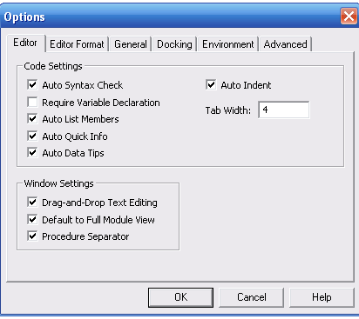
Break on all errors
All errors stop execution as soon as they occurs
Break in class module
All error in class modules stop execution as soon as they occur before they return to the calling code . support if it is as calling code . it should be specified in public and its located in another process
Break on unhandled error
Error stops execution only if there are not handle any where in program

VISUAL BASIC APPLIATIONS AND VISUAL BASIC LIBRARIES
Branch statement
Loop statement
Multiple statement
- If ……. Else…… else if……… end if
If x>0 then y=x
X=0 else y=0
Eg
  - If x>0 then
Y=x
X=0
Else
Y=0
End if

  - If ….. elseif …..end if
If x>0 then
Y=x
Elsif x<0 the
Y=x*x
Else
X=-1
End if
Single statement
- Without else
If x>0 then y
- With else
If x> 0 then y= x else y=0
Multiple condition using AND or ORoperator
- If x=0 AND y=0 then
If (x or y) = 0 then
- If x< >0 AND y< >0 then
If (x (or)y) < >0 then
XOR
If (x<0 and Y>=0) or (x>=0 and y< 0)
If (x XOR y) < 0 then

Not operator
If NOT (x = y) then

Workin gwith numbers
1.math operators
Abs
Sgn
Sqr
Exp
Log

Abs - it returns absolute value of its arguments
Sgn - it returns (-1) or (+1) respectively
Sqr - it returns the square root of numbers
Exp - raise in the base of neutral logarthims
Log - returns the natural logarthims of its arguments

2.comparision operator
< > ,<= ,>=, < >
Boolean and bitwise operator
AND,OR,NOR

Unit – IV
DIFFERENT TYPES OF CONTROLS
- [DAC ] – Data Access Object
- [ADO] – active x data object
- [RDO] – remote data object
- [ODBC] – open database connectivity
- [OLE] – object linking embedded
Data converting word into visual basic
Student mark statement
- Create a student mark statement in word
- Copy the mark statement to excel work sheet
- Then put auto sum or total for that mark statement
- Open ms access -> blank statement -> create new blank database
- Saves that database in database 2003
- Go to menu bar -> click external data -> click excel details to msaccess
- Then double click the sheet 1. it will shows all the details in ms access
Data environment
Project menu - > data environment - > ms data environment -> instance 1.0 library
Property window
Custom property
Data environment – sql empcmd – empno, empname, EMP add, empid - child
Data view
View menu – data view
4 connections
- Provider
- Connect
- Advance
- All
Cmd object - > light clicking the database or right click – select command object
Project – menu – ADO data environment
Format
Form 1 design
In access
Ms Access – file – new – blank database – no primary key – id auto number
Save that table – close table
In visual basic
Go to menu bar – project – components – select ADO or OLE control – apply – ok
Right click on the tool box – project properties – components – select ADO /OLE control – apply – ok
After clicking ok – the new object will shows on the tool bar
Select – Microsoft jet 4.0 versions – built – next – apply – ok
After that selection the option button don’t show to alter that form
ADO control selection
Project window – project page – name – apply – ok
In vb
Text1 – click properties windows in datasource select in ADODB controls – and click datafield
Select username or Empid
Text 2 – click properties windows in datasource select in ADODB controls – and click datafield
Select in that password or empname
After that click ADO button . it will shows that process of ADO or details in access wat we done in that
Crash course in SQL
DDL – data definition language
DML – data manipulation language
To retrieve and update data stored in data based
Select command
Select * from table name ;
Select pubid, company name , address from publishers
Select author, 2000 [year 2008 born] as age from authors
Aggregate functions
Select count * as author cnt avg as from authors
Combine multiple conditions using AND , OR
Boolean operators:
Select * from table name where state = “T” AND city = “C”
Comparision operators
<,>,<=,>=,=, like , between & in
Select * from table name where state = “T” and name like city =”C”
Select * from titles where [year published] between 1996 AND 1998;
Select name, statefrom publishers where state IN(‘CA’,’A’,’CS’);
SORTING & GROUPING
ORDER BY (only sorting numbers (or) fields)
Select * from publishers order by [company name];

MULTIPLE SORTING
Select * from publishers order by state , city,desc;
SORTING AND GROUPING
Select top 5 * from publishers
Descending order with year
Select top 5 * from titles order by [year published] desc;
Percentage
Selct top5 percentage * from publishers
Grouping by
Select [year published] ; count * as titles in year from titles grouping by [year published];
Before 10 years to update
Select top 10[years published] ; count (all) as title in year from titles grouping by [year published] order by [year published ] desc;
Sub queries:
To avoid ambiguities when the two tables have fields with the same name
Examples
The table name .field name which retrives a value which you can use to the left of the equal operator
Select * from titles where pubid=[selct pubid] from publishers where name = “vb”
Join
The join operator is used to retrieve data from two tables that are related to each other through a common field . the result of the join is a new table whose rows consist of some all the fields from the first table followed by some all the fields from the second tables
The expression in the class in a join command determines which rows from the second table will match a given row from the first table
The most common form join operator is left join and right join
The left join operator retrieve all the record in the first table
Syntax
Select titles.titles .[year published], publishers.name from titles left join publishers on titles .pubid = publishers.pubid
The right join operator retrieves all the records in the second tables
Union
Select name , address , city from customers union
Select company name , address, city from suppliers.
Two tables can have different structures provided that the fields return by each selct command of that the same time
Insert
Insert into command a new record to table and sets its fields in one operation
Syntax
Insert into author [author,[year born]]values [1990]
Insert into authors select * from new authors
The following copies all the record from a table called new authors into the authors tables
Update
The update command modifies the vcalue in one or more records
Syntax
Update authors set [ year born – 1961] where author = ‘fransico’
Delete
Delete command remove one or more records from a table
- Delete from titles[year published <1950]
- Delete from employees where employees last name = “guru”]
UNIT – V
DATA REPORT DESIGNER
Standard Exe – project – data report – data report environment – 6 controls
- rpt text box
- rpt label box
- rpt image
- rpt shape
- rpt line
- rpt function
project 1 – data report
project menu- data environment designer – form window will open in default
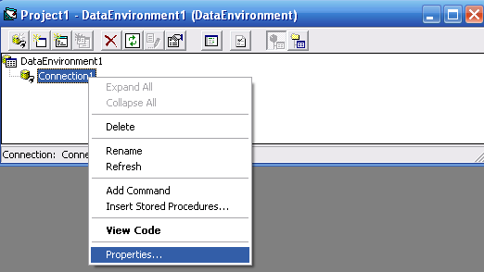
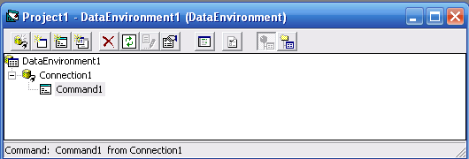
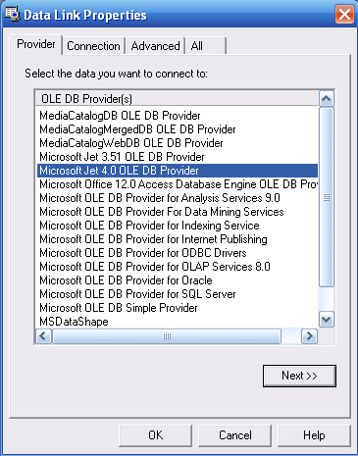
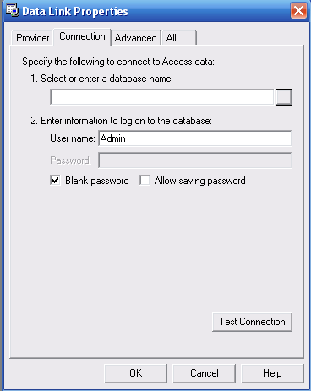
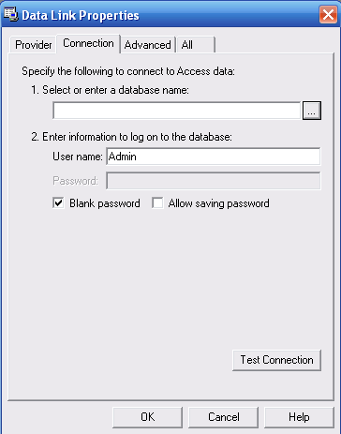
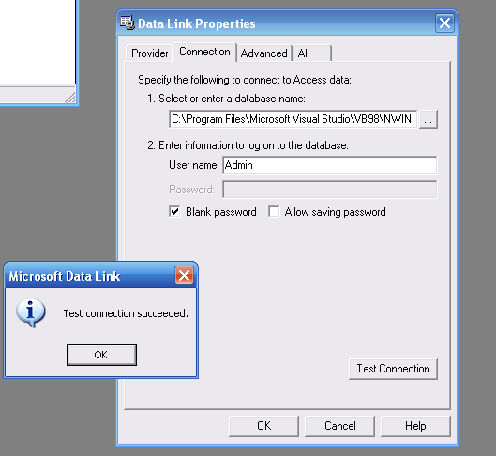
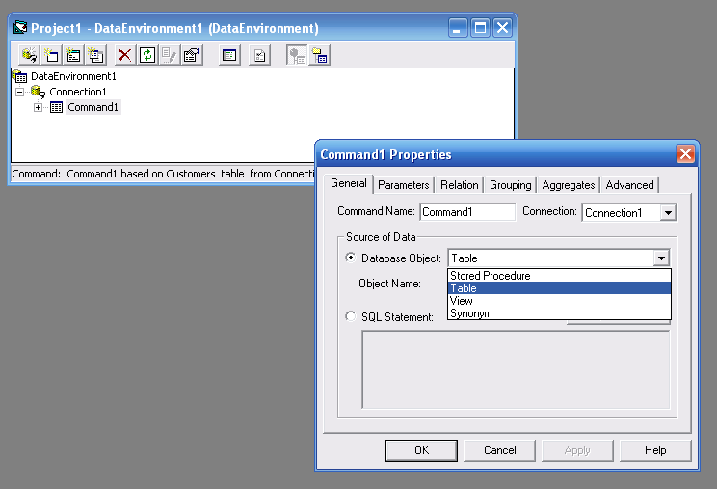

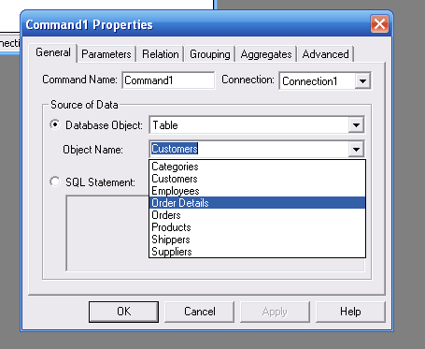

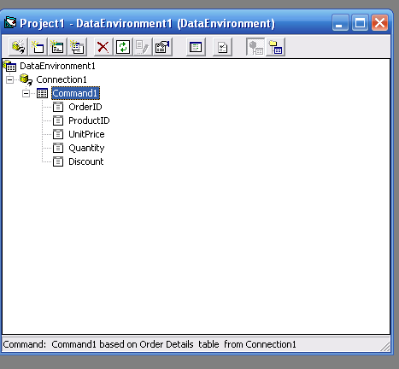

DATA BINDING
1.simple binding
2.Simple bound binding
Access empid, name,designation, salary
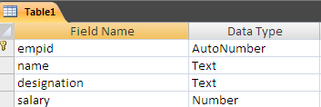
In vb
Toolbox – data tab- dropdown box- oleconnection button
data binding
- Data binding is a binding control to add from the database
- Databinding we can bind a control to a particular column in a table from the database
- We can bind the whole table to the datgrid
- Data binding provides simple convenient and powerful to create a read, write, link between the controls on a form and the data in their applications
- Window form support binding data at ADO
- A control can be bound to any collection that support index access to the elements in that collection
Simple data binding
- To display one data element from a table in a control simple binding is managed by the simple binding collection of each controls
- Simple bound controls show only one data element at a time
- In data binding property the properties are working with examples
- We will create access and access data from table with form
- To start to open a blank document in ms access and save it

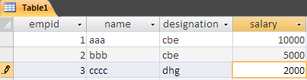
- Once you finish creating the table with required columns and enter some values and close it
- In vb new window forms are open and form the tool box add ‘8 cmd buttons’,4 label boxes, 4 text boxes
- Here we will bind data from the table we create in access to text box . if text box will display Empid, and text box , empname etc
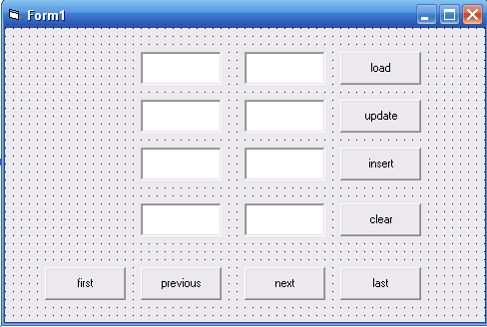

- Set the text and name property of all the buttons now the tool box click the data tab and drag ‘oledb connection object ‘ on the form
- Once the connection is object is added to the component tray open its properties window to set the connection string
- Select connection string property in the property window – click on the drop down and select new connection
- When you select new connection it opens the data link properties in that you click provider tab and select the microsoftjet4.0OLEDBProvider
- By default it select provider for SQL server and click next
- Next you takes to the connection tab here browse EMP.MDB database on the selection area by the clicking the ellipses button.
Codings
Private sub form1_load(by value sender as system object , by val sender as system
arguments)
Handles my base load
End sub
Private sub load_click()
Oledbdataadapter1.fill(dataset11)
End sub
Private sub update_click()
Try
Me.binding context (datset11,”table1”)
Me.oledbdataadapter1.update (dataset11)
Catch
End try
End sub
Private sub insert_click( )
Me.binding context(dataset11, “ table 1”).addnew( )
Msg box(“successfully inserted”)
End sub
Private sub clear _click( )
Text1.text = “ ”
Text2.text = “ ”
Text3.text = “”
Text4.text= “”
End sub
Private sub first_ click( )
Me.binding context (dataset11, “table1”).position=0
End sub
Private sub next _ click( )
Me.binidng context (dataset , “table 1”)position = 0
Me.binidng context (dataset , “table 1”)position +1
End sub
Private sub previous _ click ( )
Me.binidng context (dataset, “table 1”) position = 0
Me.binidng context (dataset, “table 1”) position - 1
End sub
Private sub last_click ( )
Me.binidng context (dataset, “table 1”) position = 0
Me.binidng context (dataset, “table 1”) count -1
End sub

DATA REPORT
Step 1: adding data report
- Vb as standard Exe project from the data report in the drop down mwnu
- You will be presented with a datareport environment
- The data report environment contains 6 controls they are
  - rpt text box
  - rpt label box
  - rpt image
  - rpt shape
  - rpt line
  - rpt function
- title to the page header using the report label as RPT label
- simply drag and draw the Rpt label control on the data report designer window and use the caption property to change the text that should be displayed
- you can also add graphics to the report using the rpt image control

Step : 2 connecting the report to database using data environment designer . click the project menu and then select data environment from the drop down menu . the default data environment will appear
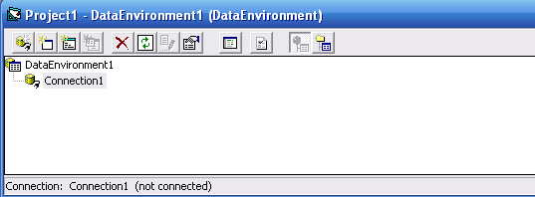
Now to connect to the data base right click connection1 and select Microsoft jet 4.0 OLEDB Database provider

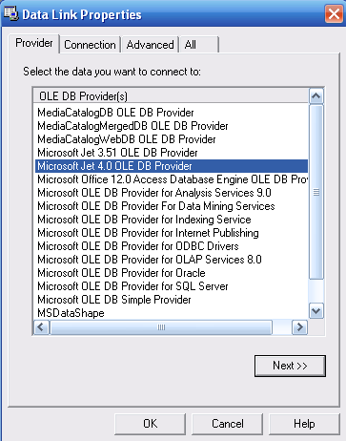

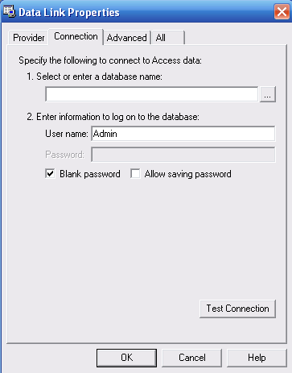
Step: 3 retrieving information from the database in order to use a database in your report. You need to create a query to retrieve the information from the database.
- Right click on my connection to add a command to the data environment

Step: 4 the default command1. Rename it is my command

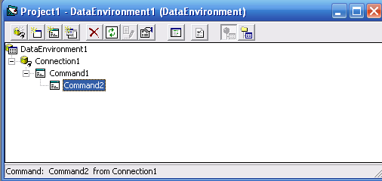

In order to use SQL command right click my command and you can its property dialog box at general tab - sql command and key in the SQL statement
This command is use to select all the field from the database
Now you need to customize of few properties of your data report , so that it can connect to the database
The first property to set its data source . the second property set my data environment next you need to set the data member property to my command . to add data to a report you need to drag in the fields from my command in my data environment into my data report as

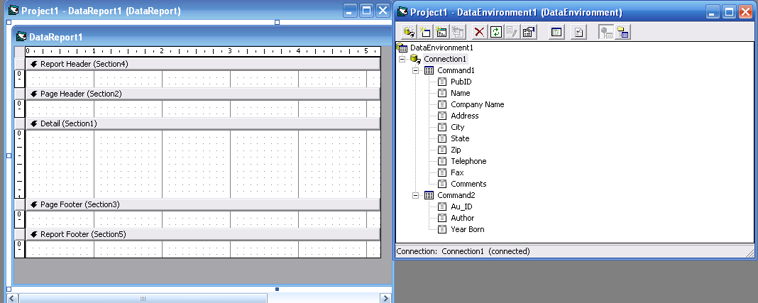

Vb automatically draw a Rpt text box along with RPT label control for each field on the report
You can customize the labels as well as the etxt box fom the property of my data report
In final step to set my data report as the start up from the project menu

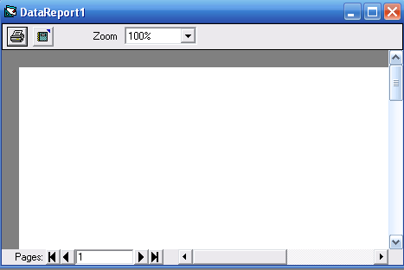
Data grid control
Project – components – msdata grid control – apply – ok
Project – components – msadodc – apply – ok
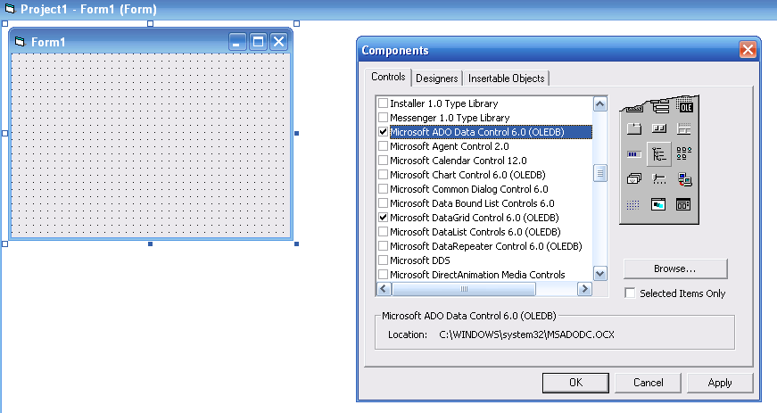

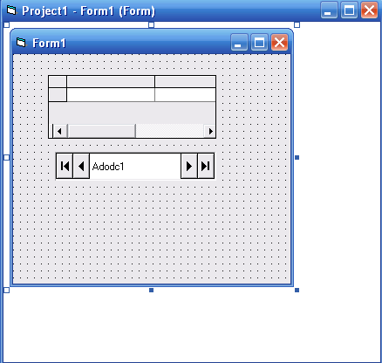

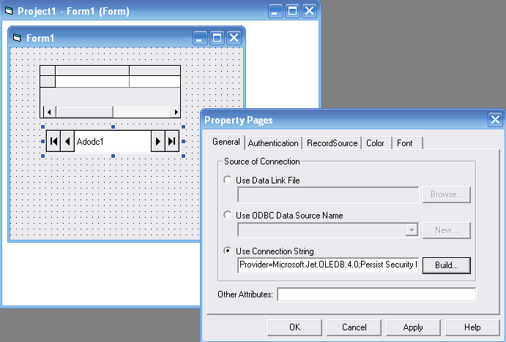

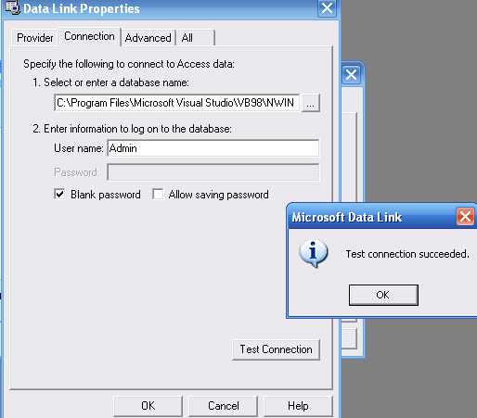

ADO control properties – record source
ADODC property – click – page dialog box – record source – dialog box will be appear on the screen
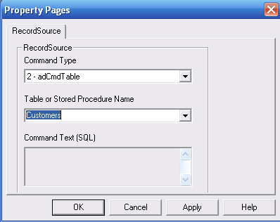
Set record source – data grid control
To display the entire table of a record set of database . it allows user to view and edit the data

Project – components – msdata grid control 6.0 – apply – ok
And select ADO control able to access the database and click ok to exit dialog box
In tool box data grid control and Ado control will be seen
To drag the dat grid control and ADO data grid control in the form
Drag the selected data from the tool box and paste it into form design
To connect database to the ADO data control right click on the ADO control and select the ADODC properties
The dialog box will be appear and click on the bulid button and next to another property will appear . in this dialog box select database file we have created
Press test connection successful . if connection is successful click ok to return to the ADODC property page dialog box . in that dialog box click record source and select the table name and stored procedure and then click ok
Finally you need to display the data in the data grid control . to accomplise this go to property of the data grid to the record

EXPLAIN ABOUT SAGA
- DAO
- RDO
- OLE
- ADO
ADO is a active database object is a programming model which means that it
is not dependent upon any given back and end. Currently the only engine supporting the
ADO model is OLEdatabase

ADO OBJECT MODEL
It consist of 60 objects
- Connection – represenst and open connection
- Error – contain details about data access error
- Command – defines a specific command
- Parameters – optional collection of the cmd object for any parameter
- Record set – it represents a set of record of set from a table , cmd object
- Field – it represent a single column of data in a record set
- Property – a collection of values raised by the provider for ADO
DAO object
It is an application program interface available with Microsoft Vb that let a programmer request access to ms access database . ADO was Microsoft first object oriented interface with database , ADO object encapsulation access jet function through jet function it analyse access other SQL database
OLE DATABASE
It is an MS strategic low level application for access to different data source ole database includes not only the sql capability of ms sponser standard data interface open database connectivity but also includes access to data
As a design form ms components object models
OLEDB is a set of methods for reading and writing data
The objects in OLEDB consist of data source object, a session object, a command object, a record set object.
RDO ( Remote Data Access Object)
RDO object and collections provide a frame work for using code to create and manipulate components of remote
ODBC vb system object collection have properties that describes the characterstics of database components and methods that you use to manipulate them
RDO object model
Rdo engine
Rdo environment
Rdo connection
Rdo query
Rdo parameter
Rdo column
Rdo prepare statement
Rdo column
Rdo tables
Rdo column
Rdo result set
Rdo parameters
Rdo connection

RDO Engine
In the basic object create automatically when access RDO in your application
RDO Error
It is used to handle all ODBC Error and message generated by RDO created automatically
RDO Environment
A logical set of connection & transaction scope for a particular user name contain both open allocated connection provider and provide the security context for DML operations on tha database RDO environment created automatically
RDO Connection
It represents an open connction to a remote data source and specific database on that data source or an allocated as unconnected object

RDO Table
It represents the stored definition of a base table or an SQL view
RDO Result Set:
It represent the row that result from running a query
RDO Column
It represents a column of data with a common data type and a common set of properties
RDO Query
An SQL query definition that can includes 0 or more parameter
RDO Parameter
It represent a parameter associated with an RDO query object, query parameter can be input or output or both

HIERARCHICAL FLEX GRID CONTROL
Project – components – ms hierarchical flex grid control – apply – ok
- It can merge contiguous cells in different rows . if they contain the same values .
- When you assign a hierarchical ADO record set to its data source property , it display multiple bands
- Each band set data column that come from a different child record set .
- To create hierarchical flex grid control is to built a hierarchical command object in a data environment designer use the right mouse button to drop it on a form and select the hierarchical flex grid command from the pop up menus
- Like data grid control the hierarchical flex grid control expose an object model

General tab

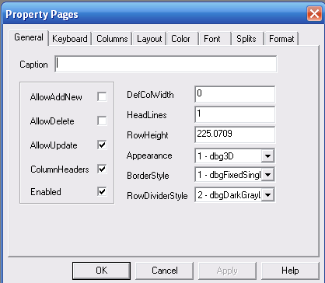

The general tab assigns a value to the controls rows, and columns properties . it determines the number of rows and columns in the grid.
The appearance will effect the control only in unbound mode
The dimension of the grid depend on the number of record and fields in the sources , fixed rows and fixed columns
The fixed rows and fixed columns properties effect , how many fixed rows and columns display at the left and on the upper border of the grid
Allow big selection property
Allow big selection property is true . clicking on a row or column , header select the entire row or column
High light property
It effect the appearance of the selected cells and can be any one
0 – flex highlight viewer
1 – flex highlight always
2 – flex highlight with focus
Focus Rect property
Determines which kinds of border appears around the current cells
0 – flex focus none
1 – flex focus light
2 – flex focus heavy
Band display property
It can change how the bands are displayed in the control and can be either
- - flex band display horizontal
- – flex band display vertical
Fill style property
In this property all the selected cells will be effected by the assignment
0 – flex fill single to one flex will repeat
Selection mode property
Decides you can select any cell
- – flex selection free
- – flex selection by row
- – flex selection by column
Allow user resizing property
The user can resize rows or columns or with a mouse
- – flex resize none
- – flex resize column
- - flex resize rows
- - flex resize both
Row resizing mode property
- – flex resizing individual
- – flex resizing all

MULTIPLE DOCUMENT INTERFACE [MDI]
Save – MDI.vbp, parent.frm, child.frm
Private sub mnnew_click ( )
Dim new form as new form1
End sub
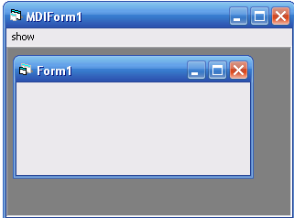

Private sub mnucascade_click ( )
Form1.windowstate = vbcascade
End sub
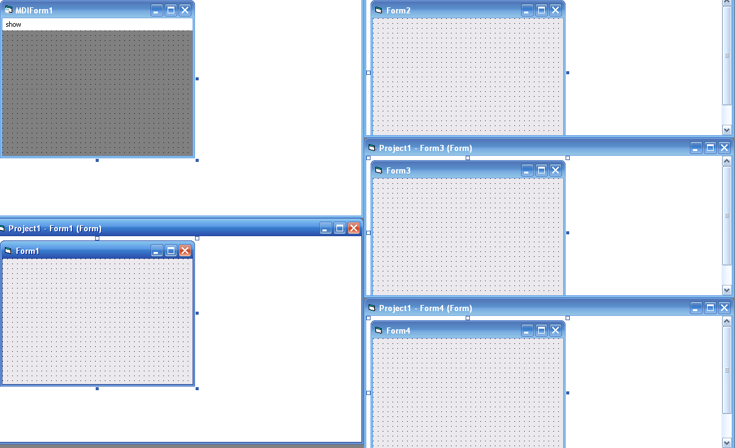
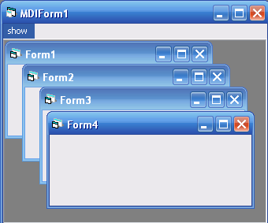

MDI stands for multiple document interface used for opening many windows at the same time . child window are contain in a parent window .
VB application has one MDI form which contains all child forms
The child window is displayed within the internal area of MDI forms
Creating an MDI applications
MDI can be designed for document in centered applications
It helps to open many similar documents at the same time
We required at least two forms one MDI form and another one child form.
Project – add MDI form
The project is saved as MDI.vbp the form is saved chid.frm . the MDI form is saved as Parent .frm
Adjusting the text box
The text box in the child form can be adjust by using resize event
The resize event is fixed whenever the size of the form is changed
Private sub form resize ( )
Me.text1.height = me. Scale height
Me.text1.width = me. Scale width
End sub
Creating a tool bars most window programs contains tool bar, provide quick access to the commonly used operation
Tool bar is also called as ribbon bar or control bar
To add tool bar , select MDi form, picture control in the tool box is double clicked
The picture box control in the MDI form cannot drag to another location in the form
Tool box are placed in picture

Creating and using controls
- Text box
A text box controls sometimes called an edit field or edit control display information entered at a design time
Properties of text box
- Text can be entered into the text box by assigning the necessary string to the text property of the control
- Multiple lines of the text in a text box controls and to set the multiple line property is true
- If a multiple line text box does not have horizontal scroll bar, text wraps automatically even when the text box is resized
- In order to customize the scroll bar combination on a text box set the scroll bar properties
- Scroll bar will always appear on a text box when its multiple property is set to true and its scroll bar property is set to anything except none or 0
- Text box controls can also act as a designation link in a DDE conversion
Sel length ( )
Returns are select or set the no of characters selected
Sel start ( )
Returns are sets the starting pointing selected text
Sel text ( )
Returns are set the string contains the currently selected text

- Label control
Label control is a graphical control you can use to display text that a user cannot change directly
Properties of label control
- We can write code that changes the caption property display by a label control in response to event at run time
- The auto size and word wrap properties should be set if the user wants to label to property display variant length lines or varying no of lines
- A label control can act as a designation in a DDE conversion
- Link topic set the conversion, link mode activate the link . link item is specify an item for the properties have been set
- Use property tot rue if you want to define a character in the caption property of the label as an access key
- Command button
A command button control is use to begin in drapt or end a process
Properties of command button
- To display text on a command button control set its caption property
- An event can be activated by clicking a command button
- A button background color can be set by setting the back color property to the desire choice
- The text color of a command button can be set using the fore color property
- The button can be enabled or disabled by setting the enable property to true or false respectively
- The button can be may visible or invisible at runtime using the visible property
- Option button control
Option button provides a set of choice form which user can select only one button by clicking it at run time , assigning the value property to true. In the code like option1.vlaue = true, using the shortcut keys specified in the caption of the label
- Using list box and combo box controls
List box and combo box controls present a set of choice that displayed vertically in a single column
If the no of items exist the value that can be displayed scroll bar with automatically appear on the control
Adding items to a list
- Design time
To add items to a list at design time click list in the property box and then add the items. Press ctrl+enter after adding each item
- Run time
The add item method is used to add item to a list at run time. The add item object
Add item_ ( ) item, index
The item argument is a string that represents the text to be added to the list
The index argument is an integer that indicates where in the list to add the new item
Removing item from the list
- Remove item method is used to remove an item from a list
Syntax
Object .removeitem index
- Selecting an item from list box
- List index property sets the index number of the currently selected item
- List count property is always one more than the index number of the last item in the list
- New index property set the index of the last item added to the list
Example
List1.additem [television]
List1.listindex = list1.new index
Sorting the list
The sorted property is set to true to enable a list to appear in alpha numeric order and falls to display the list items in the order in which they are added to the list
Combo box
Combo box combines the features of text box and list box. This control enables to the user to select either by typing the text on the combo box or by selecting a item from the list
Simple combo box
It display an edit area with an attached list box all ways visible immediately below the edit area
Drop down combo box
It can edit area with a down arrow button at the right
The list portion stays hidden until the user clicks down button to drop down the list portion
Drop down list
At run time the controls like drop down comb box. The user click the down arrow to view the list
The difference between drop down combo and drop down list combo is that edit area in the drop down list is disabled
Scroll bar controls
The scroll bar is commonly used control which enables the user to set a value by possessing it at the desire locations
The minimum and maximum property represents the minimum and maximum values
The value property of the scroll bar represent its cursor value which may be any integer between minimum and maximum values
Program:
Private sub hscroll1_ click( )
Text1.text = Hscroll1.value
End sub
Private sub command1_click( )
End
End sub
DATA ENVIRONMENT DESIGNER/ CONNECTION COMMAND OBJECT / IN REPORT
Data environment designer is a powerful sophisticated which provides an interactive design time environment for creating programs at runtime access to data. The connection command can be set at design time.
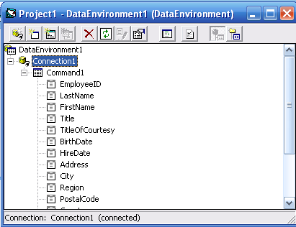
Accessing data using data environment
Data environment designer provides an essay means to access. Data in visual basic 6.0 project. Data environment designer support all 3 types of data access DAO, RDO and ADO. Data environment must include at least one connection object in it. A connection object represent a connection to a database that is used at the data source for associated commands like, tables & queries.
When ever data environment is added to visual basic project. A new connection by the name connection1 is created by default.
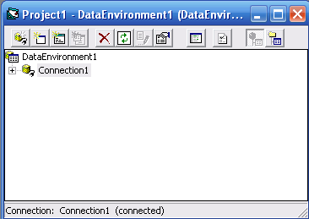
Connection object:
Connection object has 4 tabs
- Provider
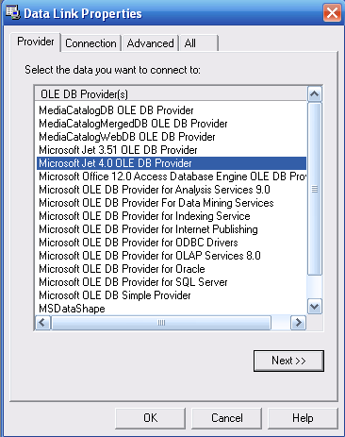
- Connection
Use to select the database provide the user id and password appropriate to the requirements of the user

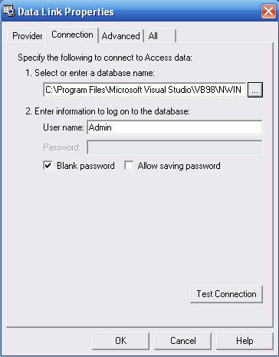

- Advanced
Used to set time out parameter
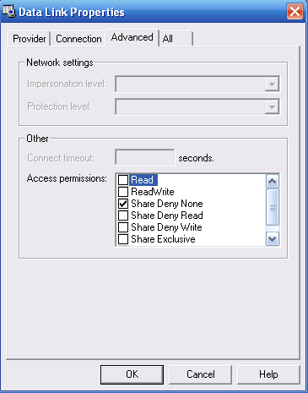

- All
Used to view a summary of the connection object settings
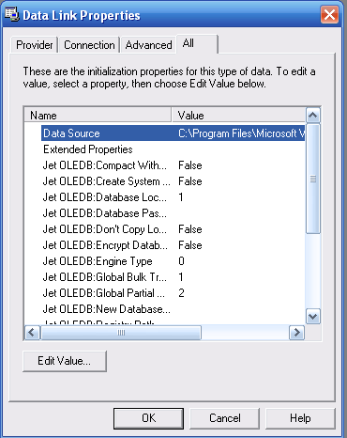

Command object
A command object is a standard active x data object
This is added to the connection object by checking add command object from the list of options
Command object has 5 tabs

- General
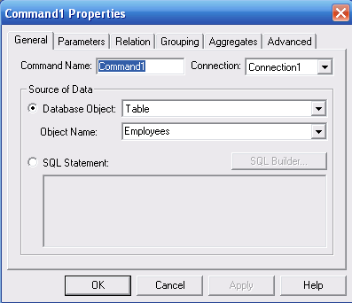
This tab is used to rename the object or change the connection object
- Parameter
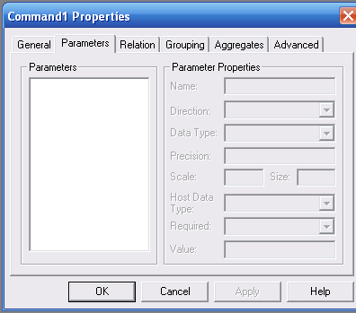

this is used to display all parameters associated with it

- Relational
This allow the develop to associated command object with each other in hierarchical relationship
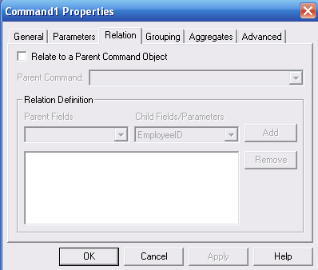

- Grouping
This tab allows the user to specify one or more columns on which the result is to be grouped
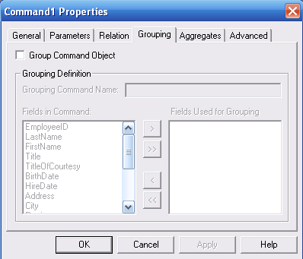
- Aggregate
This tab is to aggregate the data based on one or more several functions type
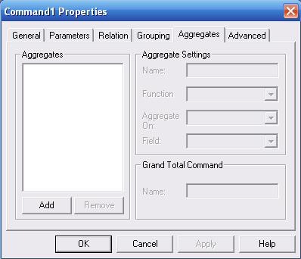
- Advanced
This tab has different option available depending on the data source
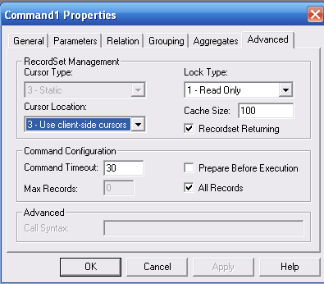

UNIT – 5
PROCESSING DATA
Opening a record set object
Source string – select command
- Dim rs as new ADODB recordset
If optsource ( 0) value then
rs.source = ‘authors’
Else if opt source(1) .value then
rs.source = ‘reptq’
Elseif optsource(2).value then
rs.source= ‘select * from authors where all names like ‘A*’
End if
- Dim rs as new ADODB recordset
If optsource ( 0) value then
rs.open “publishers” ‘’ ‘’adcmd table
Else if opt source(1) .value then
rs.open “reptq” ‘’ ‘’adcmd store proc
Elseif optsource(2).value then
rs.open = “select * from authors” ‘’ ‘’ adcmdtext
End if
Cursors & concurrency
ADODB – forward only, read only , static and dynamic
Coding
rs.cursor type = adopendynamic
rs.open = “select * from authors” ‘’ ‘’ adcmdtext
rs.open = “select * from authors” ‘’ ‘’ adopenkeyset
rs.open = “select * from optimistic, adcmd text
Stand alone record set object
- Dim rs.as new ADODB record set
rs.field.append “first name”, adchar,40,adid is nullable
cn.open “provider= sqloledb; datasource = p2;
cn.cursor loacation = acluseclient
set.rs = cn.execute(“authors”)
- Dim rs.as new ADODB record set
rs.field.append “first name”, adchar,40,adid is nullable
rs.field.append “last name”, adchar,40,adid is nullable
rs.field.append “birthdate” addate
rs.open

